MQM — Multi-Quantum Mode Transmission
"Big ALU Quantum Jump: MQM-Based Ultra-Fast HBM Transfer with Zero-Heat Architecture"
Transitioning CPU/GPU/NPU architectures from single-bit line processing to multi-dimensional MQM-based data transmission and processing.

"Not von Neumann's classical bit arithmetic — but computation through physical wave interference."
"Nature is arithmetic. Entrust computation to waves and light( 4칙연산을 자연에 맡겨라..)

[ 1]. Fundamental Knowledge for MQM-ALU Design( MQM-ALU 만들기전 기초 지식 )
💡 Core Technology: 3D-Mapping Transfer
A revolutionary data transmission method that maps information into a 3D Symbol Space within a single cycle.
A single data symbol = ( Frequency, Amplitude, Phase )
1-cycle data → 3D-mapping → High-speed transfer
$$S(t)=A⋅sin⁡(2πft+ϕ)$$
Dimension | Role
Frequency (f) | Multi-carrier modulation (OFDM)
Amplitude (A) | Multi-level signaling (PAM/MQM)
Phase (φ) | Phase shift keying

📐 Core Formula
Data Transfer Throughput = [ Frequency (n bits) + Amplitude (m bits) ] × 2^p
Symbol | Description | Example
n | Bits encoded in the Frequency dimension | 8 bits → 256 states
m | Bits encoded in the Amplitude dimension | 8 bits → 256 levels
p | Phase bits | 3 bits
2^p | Phase states (= Phase Number) | 3 bits → 8 states
Key Point: Phase is defined by bit count (p), yielding 2^p independent phase slots. With p=3: 3 phase bits → 8 phase states (0°, 45°, 90°, 135°, 180°, 225°, 270°, 315°) → (n + m) × 2^p bits transmitted per cycle, per channel.
📊 Frequency : F(n)= base + 2^(n-1) x scaling factor
; ( n: 1이상의 자연수 , Base : 중심 주파수/진폭, scaling factor : 하드웨어 인식위한 증폭이나 감량 수. )
📊 Amplitude : A(m)= base + 2^(m-1) x scaling factor
( m : 1이상의 자연수 , Base : 중심 주파수/진폭, scaling factor : 하드웨어 인식위한 증폭 수. )
📊 Phase bits → Phase states
Phase bits (p) | Phase states (2^p)
1 | 2
2 | 4
3 | 8
4 | 16
8 | 256

📊 Efficiency Example (n=8, m=8, p=3)
Dimension | Bits | States
Phase (φ) | 3 bits | 8 independent slots (0° ~ 315°)
Frequency (f) | 8 bits | 256 states per slot
Amplitude (A) | 8 bits | 256 levels per slot
Total capacity: (8 + 8) × 2^3 = 16 × 8 = 128 bits (16 Bytes) per cycle

🔧 Designer-Defined Bit Sequence Mapping
The assignment of n bits and m bits to the leading or trailing bit sequence is freely chosen by the system designer:
Option | Leading bits | Trailing bits
Option A | → Frequency (n bits) | → Amplitude (m bits)
Option B | → Amplitude (m bits) | → Frequency (n bits)
Key Point: MQM does not mandate a fixed mapping — the designer selects freely based on hardware constraints and optimization goals.

📜 MQM Design Freedom — 6 Configuration Options
In MQM, Frequency (F), Amplitude (A), Phase (P) can each serve as either Data or State.
The system designer chooses freely based on hardware environment.
Case 1: State × 1 + Data × 2 (3 options)
# | State (배율) | Data 1 | Data 2 | Formula of data Throughput
A) | Phase(z bit) | Frequency(n bits) | Amplitude(m bits ) | [F(n) + A(m)] × 2^z ←기본MQM
B) | Frequency(n bits) | Phase(z bit) | Amplitude(m bits ) | [Phase(z) + A(m)]
C) | Amplitude(m bits ) | Frequency | Phase | [F(n) + Phase(z)]
- Best performance : case 1. A)
→ ex) Data 1, Data 2 : 1st byte (Data 2) 2nd byte(Data 1) 등 적절히 바꿔서 설계가능
→ ex) Data 1, Data 2 : 1st byte (Data 1) 2nd byte (Data 2) 등 적절히 바꿔서 설계가능

[2]. Architecture Overview: The MQM-ALU (E)
The MQM-ALU transcends traditional Boolean logic by replacing gate-level switching with wave-based interference. By encoding 128 bits ( 16 bytes) of data into a single complex wave state—defined by frequency (F), amplitude (A), and phase (Φ)—the architecture enables massive parallel processing at the physical layer.

1. Core Data Specification (The MQM Cell)
- Structure: ( F(8bit) + A(8bit) ) x 2^3(phase )
- Payload: 128 bits (16 bytes) per processing cell.

2. Operational Principles : "Wave-based Arithmetic Operations"
"Not von Neumann's classical bit arithmetic — but computation through physical wave interference."
Unlike traditional CPUs that execute instructions through sequential transistor toggling, the MQM-ALU treats arithmetic as physical interference phenomena:
- Summation (A+B): Achieved via constructive wave interference.
- Subtraction (A-B): Achieved via destructive interference (phase inversion by Φ ).
- Multiplication (A x B): Executed through frequency mixing/heterodyning.
- Division (A / B ): Executed through logarithmic amplitude scaling and phase subtraction.
1) SUM (n1 Hz on m1 mV, n2 Hz on m2 mV):
- Mechanism: Constructive wave interference= 두 파동의 중첩(Superposition).
- Sum_wave =(f1, A1) + (f2, A2)
2) Subtraction or MINUS (n1 Hz on m1 mV, n2 Hz on m2 mV):
- Mechanism: Destructive interference via Φ phase inversion
= 위상 반전을 이용한 간섭(Destructive Interference).
- minus_wave = (f1, A1) - (f2, A2)
3) MULTIPLY (n1 Hz on m1 mV, n2 Hz on m2 mV):
- Mechanism: Frequency mixing/heterodyning = 주파수 혼합(Frequency Mixing/Heterodyning).
- multiply_wave = (f1, A1) x (f2, A2)
4) DIVIDE (n1 Hz on m1 mV, n2 Hz on m2 mV):
- Mechanism: Logarithmic amplitude scaling and phase subtraction.= 진폭 스케일링 및 위상 감산.
- 표기 제안: Divide_wave = (f1, A1) / (f2, A2)

Implementation Logic
The operations function by processing the wave data directly through the ALU’s interference core. The workflow is as follows:
- Input: Wave data 1 and 2 are received via optic or wire channels.
- Execution: The ALU performs interference-based calculation in O(1) constant time.
- Output: The resulting wave state is either decoded into bits for register storage or preserved as a wave state in the ALU register.
This structure effectively demonstrates the transition from bit-sequential processing to physical wave-block processing.
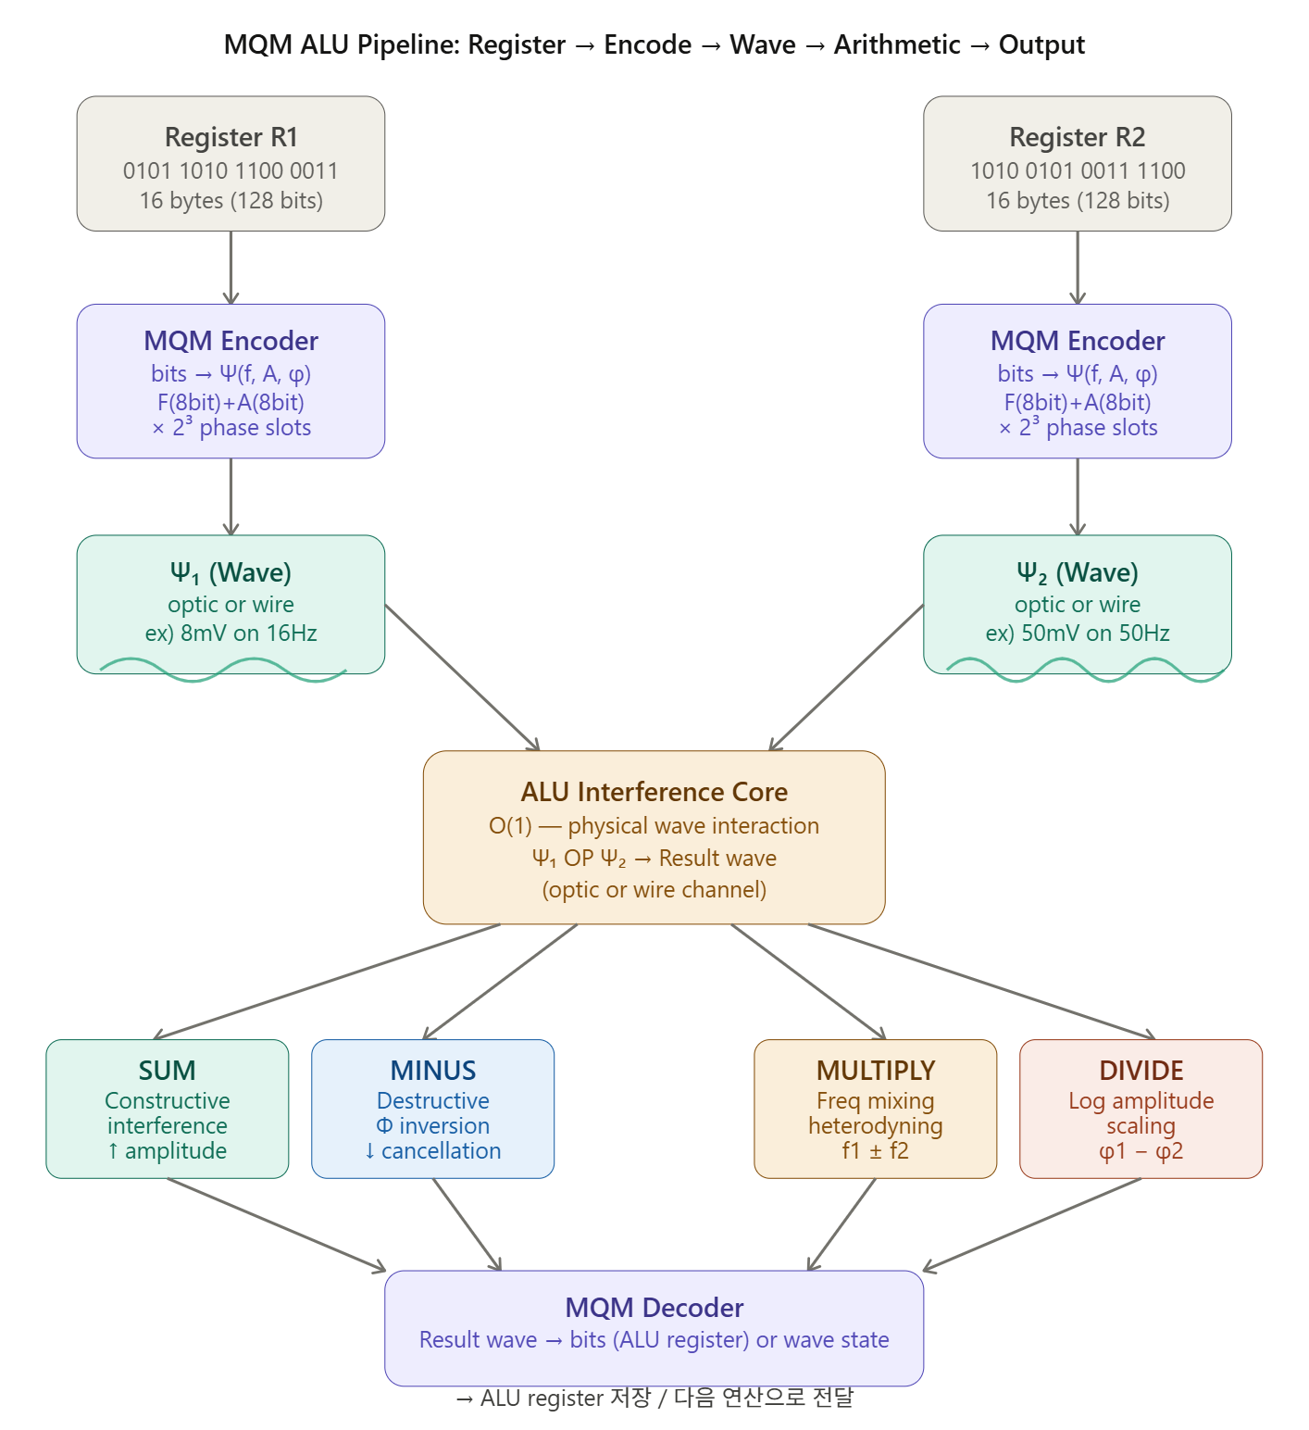
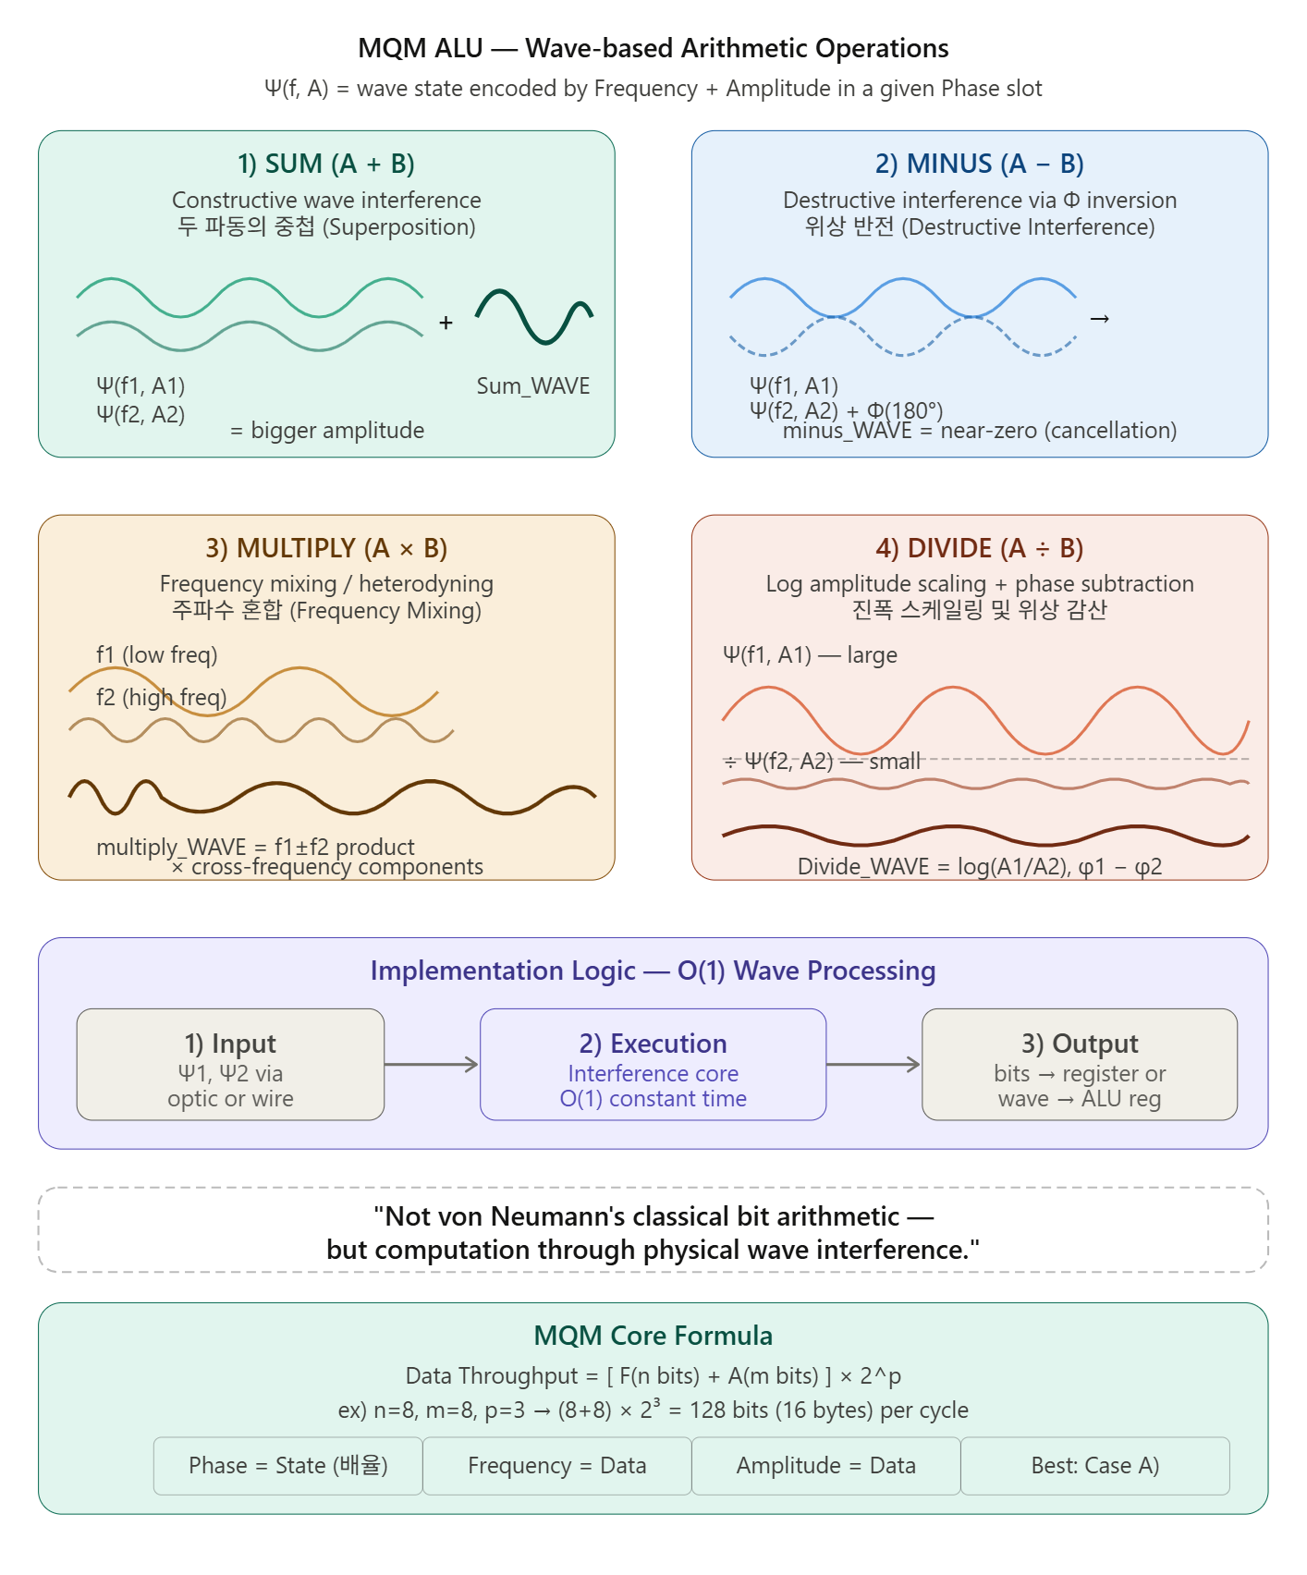

3. MQM ALU Reality
Data = Frequency (8bit), Amplitude (8bits)
= 16bits (2bytes example)
Phase is added at external connection
(CPU ↔ External)

CPU internal Interface External (HBM, PCIe etc)
───── ──────── ──────────
F + A ───→ Phase encoding added ───→ F + A + P (Full MQM)

W3(FA) created internally,
Phase layer added at output stage

* CPU Internal : MQM 2D (F + A (or + Phase))
→ Speed & stability first
→ With Phase: even more operations per cycle

* CPU External : MQM 3D (F + A + P)
→ Density & noise immunity first

[ Schema : 10 GHz MQM ALU
50ps (data transfer) + 50ps (noise cancelling) ]

- Implementation method is freely determined
by developers according to technological advancement

3.1.MQM ALU Operation Schema : Without Phase consideration
→ When Phase is included, 2^z operations are executed per cycle.
Phase | Vs. Conventional CPU
No Phase | X 16 (16bit operation , 1cycle)
Phase z=3bit ( 8 phase) | X 128( 16x8 bit operation, 1cycle)
Phase z=8bit( 256 phase ) | x 4096( 16x256 bit operation, 1cycle)
Phase z=14bit ( 2^14 phase) | X 32768( 16x2^14 bit operation, 1cycle)
"Insanely fast — orders of magnitude beyond conventional architecture."
(아따 허벌나게 빠르구마이)

# Signal Propagation Distance Based on Speed of Light
Speed of Light : 300,000 km/s = 3×10¹¹ mm/s
1000 GHz = 10¹² Hz => 1 cycle = 1 / 10¹² s = 1 ps
100 GHz = 10¹¹ Hz => 1 cycle = 1 / 10¹¹ s = 10 ps
10 GHz = 10¹⁰ Hz => 1 cycle = 1 / 10¹⁰ s = 100 ps ( 현재 2026년 과학 수준 )

Distance traveled by light during 1ps (1000 GHz, 1 cycle) : 3×10¹¹ mm/s ÷ 10¹² = 0.3mm
Distance traveled by light during 10ps (100 GHz, 1 cycle) : 3 mm
Distance traveled by light during 100ps (10 GHz, 1 cycle) : 30 mm
1) Clock Frequency : 10 GHz ALU
2) Bits/Cycle : 16 bit (1 × W3)
3) Throughput : 10G × 16bit = 160 Gbps
4) Modulation : F + A (2D, CPU internal)
5) Transmission : Differential (W3 / -W3)
6) Data Window : 10 ps (1/100 × 10GHz cycle)
7) NC (Noise Cancelling) interval : 90 ps
8) 1 cycle = 100 ps (10ps data transfer + 90ps NC)
→ Cycle frequency = 1 / 10ps = 100 GHz
9) Wire Length (Photon-scaled wire length) :
= "Light travel distance per 1 cycle × Scale factor"
= 30mm × 0.4 = 12mm

W1 (2byte) ─┐
├─[MQM합: SUM/MINUS/DIVIDE/MULTIPLY ]─→ W3 (synthesized wave)
W2 (2byte) ─┘ │
├──→ 1st wire : +W3
└──→ 2nd wire : -W3 (inverted)
W1 = 16bit = F1(8bit) + A1(8bit)
W2 = 16bit = F2(8bit) + A2(8bit)
W3 = Synthesized wave of W1 and W2 → Result waveform of arithmetic operations

3.2. MQM Timing Structure (10 GHz ALU basis)
Resolves heat and noise issues of conventional Bit ALU beyond 6 GHz
Interval | Time | Role
1/100 GHz | 10ps | Actual data transfer window
9/100 GHz | 90ps | Noise Cancelling interval
합계 | 100ps | 1 cycle (10GHz)
Data transfer : NC (Noise Cancelling) = 1:9
(As NC technology improves, ratio may reach 100:0)

3.3. MQM Operating Principles
1) MQM 2-Wave Synthesis (W3 Generation)
W1 : F1 + A1 (2byte = 16bit data)
W2 : F2 + A2 (2byte = 16bit data)
─────────────────────────────────────────
W3 = W1 ⊕ W2 → F+A 2D simultaneous modulation (MQM unique characteristic)
▷ MQM FA Synthesis — 2 officially defined methods.
Choose whichever is easier to implement with current technology.
① Method 1 — Natural Superposition
Ex) W1 = 3Hz on 7mV
W2 = 16Hz on 255mV
W3 = Complex waveform (two components coexist)
-> Transmission : Very easy
-> Reception : FFT separation required
-> Feature : Follows natural physics law
② Method 2 — MQM FA Arithmetic Synthesis
Ex) W1 = 3Hz on 7mV
W2 = 16Hz on 255mV
W3 = 19Hz on 262mV (single waveform)
Ex) Frequency : F(n)= base + 2^(n-1) x scaling factor
; ( n: natural number ≥ 1, Base: center frequency/amplitude,
scaling factor: amplification or reduction value for hardware recognition )
[ Base= 1GHz, scaling factor = 0.001 ]
N= 1: 1.001Ghz, 2 : 1.002GHz, 3 : 1.003Ghz, 255 : 1.255GHz
-> Transmission : Generate after F+F, A+A operation
-> Reception : Simple measurement (1 frequency + 1 amplitude)
-> Feature : Simple MQM method

2) Differential Signaling
1st Wire : +W3
2nd Wire : -W3 ← Fully inverted phase

→ When external noise N is introduced:
1st = W3 + N
2nd = -W3 + N
Receiver differential: (W3+N) - (-W3+N) = 2×W3 ✓ Noise eliminated

3) Data Reading at specific point (e.g. 9mm)
• Sampling +W3 signal within 1ps window
• MQM F+A+P simultaneous demodulation
→ W1, W2 separated and restored

4) Physical short at specific point (e.g. 12mm) → Signal Flat
1st(+W3) + 2nd(-W3) = 0 → Complete cancellation

Termination eliminates reflected waves,
stabilizes transmission line.
( others method : Differential termination or Matched termination )

▷ 4 Arithmetic Operations — ALU perspective
ADD : W3 = W1 + W2 → Frequency summation
SUB : W3 = W1 - W2 → Phase inversion synthesis
MUL : W3 = W1 × W2 → Amplitude modulation overlap
DIV : W3 = W1 / W2 → Frequency division

4. If MQM ALU is Applied:
- MatMul multiplication/addition → O(1) processing via wave mixing and superposition
- Data transfer between HBM ↔ NPU → Explosive bandwidth increase through MQM encoding
- Heat generation → Fundamentally resolved by Zero-Heat Architecture

5. MQM ALU Design Philosophy:
"Not classical bit-to-bit arithmetic, but computation through physical wave interference."

Feature | Traditional CPU (Sequential) | MQM-ALU (Parallel Interference)
Logic Basis | Boolean Gate Switching | Waveform Superposition
Computation Time | O(N) (Gate delay accumulation) | O(1) (Propagation delay)
Data Handling | Bit-serial/Word-parallel | Wave-block processing (16 bytes)
Throughput | Limited by clock/gate latency | Limited by bandwidth/wave integrity

Technological Impact
The MQM-ALU functions as a Digital Quantum Simulator. By mapping the state-space of quantum parallel processing onto high-frequency analog wave mechanics, the architecture achieves quantum-equivalent throughput in a deterministic, solid-state environment.
- Deterministic Efficiency: Unlike quantum systems that rely on probabilistic outcomes, the MQM-ALU maintains 100% digital integrity via its Encoder/Decoder pipeline.
- Scalability: Computational time remains constant regardless of data width, effectively bypassing the "Memory Wall" that plagues traditional von Neumann architectures.

[2].MQM-ALU Design:ex) Frequency(8bits), Amplitude(8bits), phase( 3bits=8phase or states) (k)
Korean version : [2]

1. Core Data Specification (The MQM Cell)
- Structure: ( F(8bit) + A(8bit) ) x 2^3(phase )
- Payload: 128 bits (16 bytes) per processing cell.
ex) Frequency(8bits), Amplitude(8bits), phase( 3bits = 8phase or states) : ( 8 +8) x 8 bits = 128bits (16bytes)

2. Operational Principles : 고전적 bits간 연산이 아니라, wave 연산
“RAM의 MQM encoder로 들어온 파동 data를
파동data [ optic, wire ; 예, (phase 1) 8mv on 16hz , (phase2) 50mv on 50hz ] 간의
sum, minus, multiply, divide
=> MQM decoder로 결과값을 bit로 추출 ALU register 저장 or
계산된 파동 data를 ALU register에 저장 “
1) SUM (n1 Hz on m1 mV, n2 Hz on m2 mV):
- Mechanism: Constructive wave interference= 두 파동의 중첩(Superposition).
- Sum_WAVE =(f1, A1) + (f2, A2)
2) Subtraction or MINUS (n1 Hz on m1 mV, n2 Hz on m2 mV):
- Mechanism: Destructive interference via Φ phase inversion
= 위상 반전을 이용한 간섭(Destructive Interference).
- minus_WAVE = (f1, A1) - (f2, A2)
3) MULTIPLY (n1 Hz on m1 mV, n2 Hz on m2 mV):
- Mechanism: Frequency mixing/heterodyning = 주파수 혼합(Frequency Mixing/Heterodyning).
- multiply_WAVE = (f1, A1) x (f2, A2)
4) DIVIDE (n1 Hz on m1 mV, n2 Hz on m2 mV):
- Mechanism: Logarithmic amplitude scaling and phase subtraction.= 진폭 스케일링 및 위상 감산.
- 표기 제안: Divide_WAVE = (f1, A1) / (f2, A2)

Implementation Logic
The operations function by processing the wave data directly through the ALU’s interference core. The workflow is as follows:
1) Input: Wave data 1 and 2 are received via optic or wire channels.
2) Execution: The ALU performs interference-based calculation in O(1) constant time.
3) Output: The resulting wave state is either decoded into bits for register storage or preserved as a wave state in the ALU register.
This structure effectively demonstrates the transition from bit-sequential processing to physical wave-block processing.
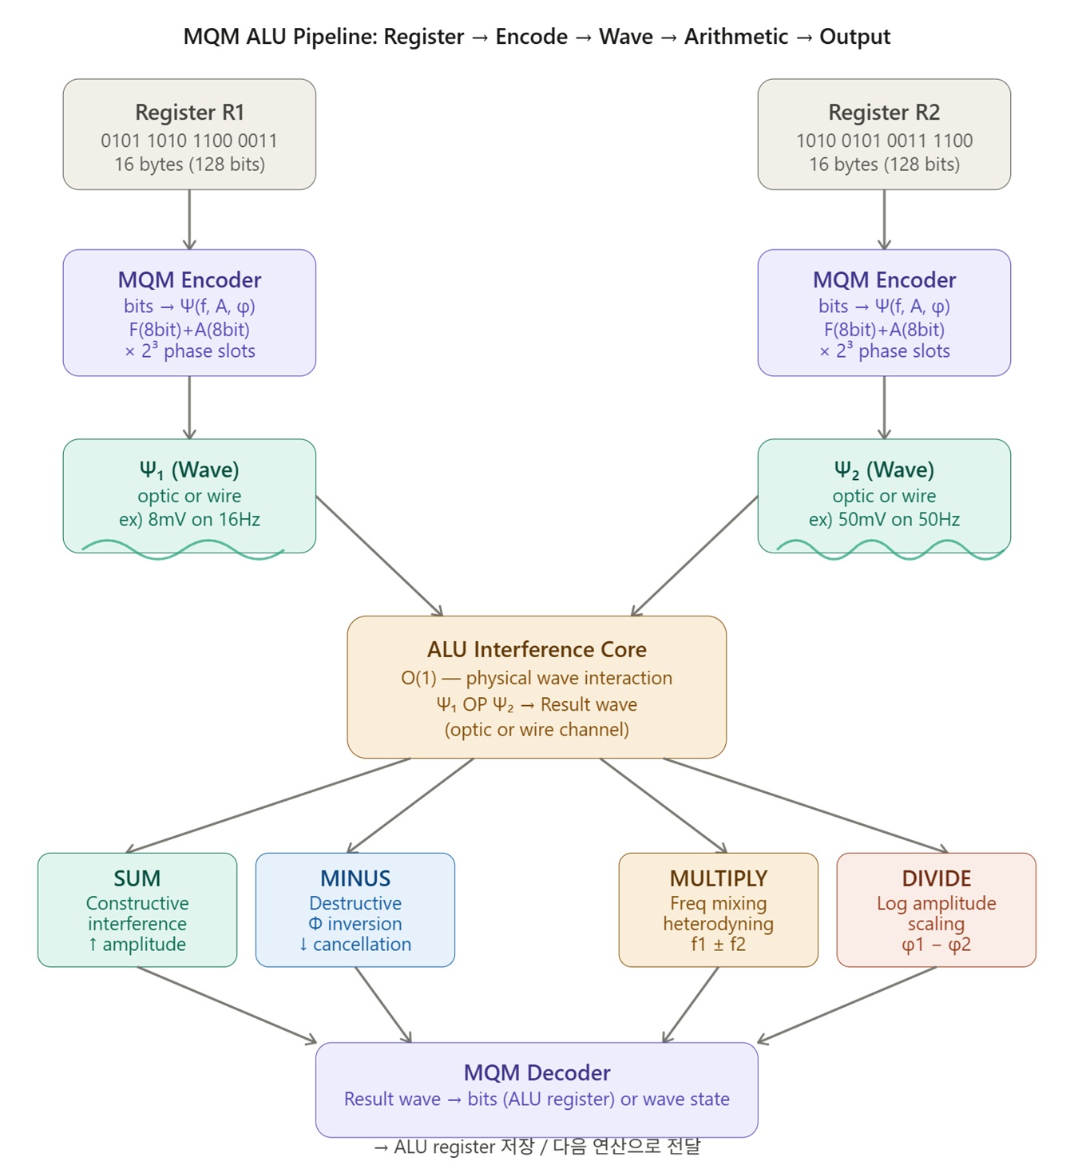
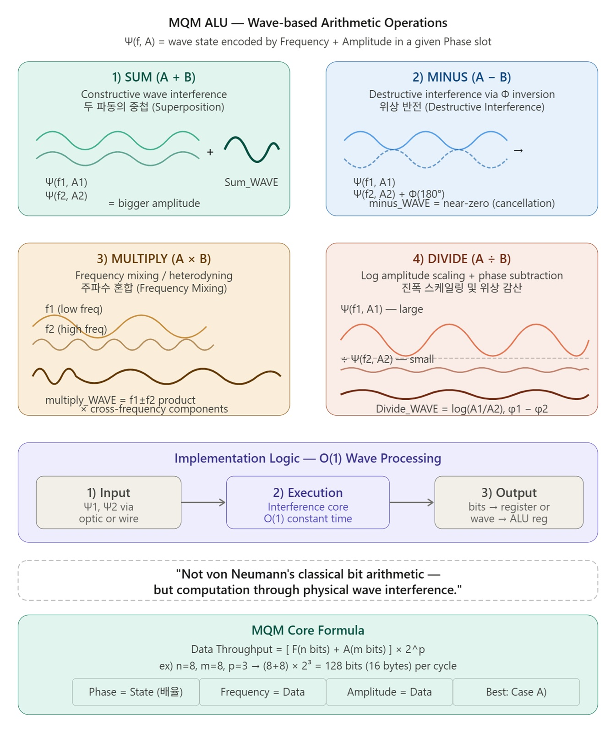

3. MQM ALU Reality
Data = Frequency ( 8bit) , Amplitude ( 8bits ) 16bits ( 2bytes example )
외부 연결 (CPU ↔ 외부) 에서는 Phase 추가

CPU 내부 인터페이스단 외부 (HBM, PCIe 등)
───── ──────── ──────────
F + A ───→ Phase 인코딩 추가 ───→ F + A + P (완전 MQM)

내부에서 만든 W3(FA)에
출력단에서 Phase 레이어를 덧씌움

* CPU 내부 : MQM 2D (F + A ( or + phase) → 속도·안정성 우선, phase까지 추가시 더 많은 연산
* CPU 외부 : MQM 3D (F + A + P) → 밀도·노이즈 내성 우선
[ schema : 10 GHz MQM ALU 50 Ps ( data transfer) , 50 Ps ( noise cancelling ) 방식 ]
- 구현방식은 개발자가 자유롭게 기술 발전에 따라 설정 :

3.1. MQM ALU 동작 schema : Phase를 고려 하지 않는 경우
Phase 를 고려하면 2^z 만큼 1cycle에 연산 시행…
Phase | 기존 CPU 대비
Phase 없음 | 기존 CPU 대비 ~16배( 16bit연산 1cycle)
Phase z=3bit ( 8 phase) | 기존 CPU 대비 ~128배( 16x8 bit연산 1cycle)
Phase z=8bit( 256 phase ) | 기존 CPU 대비 ~4096배( 16x256 bit연산 1cycle)
Phase z=14bit ( 2^14 phase) | 기존 CPU 대비 ~32768배( 16x2^14bit연산 1cycle)
"Insanely fast — orders of magnitude beyond conventional architecture."
(아따 허벌나게 빠르구마이)

# 빛의 속도 기반 신호 전파 거리.
빛의 속도 : 300,000 km/s = 3×10¹¹ mm/s
1000 GHz = 10¹² Hz => 1 cycle = 1 / 10¹² s = 1 ps
100 GHz = 10¹¹ Hz => 1 cycle = 1 / 10¹¹ s = 10 ps
10 GHz = 10¹⁰ Hz => 1 cycle = 1 / 10¹⁰ s = 100 ps ( 현재 2026년 과학 수준 )

1ps (1000 GHz 1cycle )동안 빛이 가는 거리:3×10¹¹ mm/s ÷ 10¹² = 0.3mm
10ps (100 GHz 1cycle ) 동안 빛이 가는 거리 : 3 mm
100ps (10 GHz 1cycle ) 동안 빛이 가는 거리 : 30 mm
1) 신호 주파수 : 10 GHz ALU
2) 비트/사이클 : 16 bit (W3 1개)
3) 처리량 : 10G × 16bit = 160 Gbps
4) 변조 차원 : F + A (2D, CPU 내부)
5) 전송 방식 : 차동 (W3 / -W3)
6) 데이터 윈도우 : 10ps (1/100 × 10GHz 주기)
7) NC( Noise cancelling ) 구간 : 90ps
8) 1 cycle = 100ps (10ps data transfer + 90ps NC)
→ 사이클 주파수 = 1 / 10ps = 100GHz

9) 도선 길이(Photon-scaled wire length) :
= “빛의 1cycle당 이동거리 x 배율”= 30mm x 0.4= 12mm

W1 (2byte) ─┐
├─[MQM합: SUM/MINUS/DIVIDE/MULTIPLY ]─→ W3 (합성파)
W2 (2byte) ─┘ │
├──→ 1st 도선 : +W3
└──→ 2nd 도선 : -W3 (역위상)
W1 = 16bit = F1(8bit) + A1(8bit)
W2 = 16bit = F2(8bit) + A2(8bit)
W3 = W1과 W2 합성파로 4칙 연산 결과 파형

3.2. MQM 타이밍 구조 (10 GHz ALU 기준)
Bit ALU의 6 GHz 넘을 때 발열 문제, Noise 문제 해결

구간 | 시간 | 역할
1/100 GHz | 10ps | 실제 데이터 전송 윈도우
9/100 GHz | 90ps | Noise Cancelling 구간
합계 | 100ps | 1 사이클 (10GHz)
Data transfer : NC ( Noise canceling) = 1:9 (NC 기술 향상시 100:0 될 수도 )

3.3. MQU 동작 원리
1) MQM 2파 합성 (W3 생성)
W1 : F1 + A1 (2byte = 16bit 데이터)
W2 : F2 + A2 (2byte = 16bit 데이터)
─────────────────────────────────────────
W3 = W1 ⊕ W2 → F+A 2차원 동시 변조
(MQM 고유 특성)
▷ MQM FA 합성방식 ( ①, ② ) — 2가지 방식 공식 정의, 현재 기술로 구현 하기 쉬운 걸로
① Method 1 — Natural Superposition
예) W1 = 3Hz on 7mV
W2 = 16Hz on 255mV
W3 = 복합 파형 (두 성분 공존)
-> 송신 : 매우 쉬움
-> 수신 : FFT 분리 필요
-> 특징 : 자연 물리 법칙 그대로

② Method 2 — MQM FA Arithmetic Synthesis
예 W1 = 3Hz @ 7mV
W2 = 16Hz @ 255mV
W3 = 19Hz @ 262mV (단일 파형)
Ex) Frequency : F(n)= base + 2^(n-1) x scaling factor
; ( n: 0이상의 자연수 , Base : 중심 주파수/진폭, scaling factor : 하드웨어 인식위한 증폭이나 감량 수. )
[ Base= 1GHz, scaling factor = 0.001 인경우 ]
N= 1: 1.001Ghz, 2 : 1.002GHz, 3 : 1.003Ghz, 255 : 1.255GHz
->송신 : F+F, A+A 연산 후 생성
->수신 : 단순 측정 (주파수 1개, 진폭 1개)
-> 특징 : 간단한 MQM 방식

2) 차동 전송 (Differential Signaling)
1st 도선 : +W3
2nd 도선 : -W3 ← 완전 역위상

→ 외부 노이즈 N 유입 시:
1st = W3 + N
2nd = -W3 + N

수신단 차분: (W3+N) - (-W3+N) = 2×W3 ✓ 노이즈 제거

3) 특정 (9mm 등에서 )지점 데이터 읽기
- 1ps 윈도우에서 +W3 신호 샘플링
- MQM F+A+P 동시 복조 → W1, W2 분리 복원

4) 특정 (12mm 등에서 ) 물리 연결 → Signal Flat
1st(+W3) + 2nd(-W3) = 0 → 완전 상쇄
종단 처리로 반사파 제거, 선로 안정화

▷ 4칙연산 ALU 연결 관점
ADD : W3 = W1 + W2 → 주파수 합산
SUB : W3 = W1 - W2 → 위상 반전 합성
MUL : W3 = W1 × W2 → 진폭 변조 중첩
DIV : W3 = W1 / W2 → 주파수 분할

4. MQM ALU가 적용되면:
- MatMul의 곱셈/덧셈 → 파동 혼합/중첩으로 O(1) 처리
- HBM ↔ NPU 간 데이터 이동 → MQM 인코딩으로 대역폭 폭발적 증가
- 발열 → Zero-heat architecture로 근본 해결

5. MQM ALU Design Philosophy:"고전적 bits연산이 아니라, 파동간의 연산"
"Not von Neumann's classical bit arithmetic — but computation through physical wave interference."
Feature | Traditional CPU (Sequential) | MQM-ALU (Parallel Interference)
Logic Basis | Boolean Gate Switching | Waveform Superposition
Computation Time | O(N) (Gate delay accumulation) | O(1) (Propagation delay)
Data Handling | Bit-serial/Word-parallel | Wave-block processing (16 bytes)
Throughput | Limited by clock/gate latency | Limited by bandwidth/wave integrity

6. 16bytes register 고전적 ALU 와 MQM ALU성능 비교
# 16bytes register인 R1, R2 sum연산이나
16bytes MQM 파동 M_R1, M_R2 sum연산 속도 차이(추정 )

비교 항목 | 기존 CPU (16bytes Sum) | MQM ALU (16bytes Sum)
연산 원리 | 비트 단위 가산기 연쇄 (순차) | 파동의 물리적 중첩 (즉각)
소요 시간 | 수 클럭 사이클 (게이트 지연 누적) | 신호 전파 시간 (물리적 지연)
처리 효율 | 비트 폭 증가 시 지연 시간 증가 | 데이터 폭 증가 시에도 시간 불변
속도 격차 | 기준 (1x) | 이론적 수십 배 ~ 수백 배 이상

📜 GitHub: https://github.com/scwpark/MQM-PAM_OFDM_Phase-superposition_3D-mapping
- Community: https://cafe.daum.net/scwpark

☕ Buy Me a Coffee
MQM is free and open-source forever — no patent, no fee. If MQM helped you, a cup of coffee keeps this old doctor-inventor going! 🦋
👉 Buy Me a Coffee
Or directly via Shinhan Bank (신한은행):
- 예금주: PARK SUNG TAE (박성태)
- SWIFT: SHBKKRSE
- Account: 110-623-275173
"I had this dream in the 1980s. Forty years later, I'm giving it to the world for free. A coffee would be nice though." ☕😄

